Eric Design Document

**1) Goals and mission:**

My websites mission is to teach people what really is inside the Bible, its lessons and effects on people through pictures and a simple explanation of the picture and a lesson. Not only will it attract all kinds of people interested in photography, but with it, we can find new talented photographers willing to do what they love while benefitting others’ lives.

My goal is to gather several talented and eager photographers to take pictures that will help teach people trying to figure out what the Bible is, but don’t feel like they have a lot of time to put into reading the Bible. I will start off with one photographer, which is me. The website will have a feature that lets people from around the country send an application of wanting to help me take pictures. My overall goal is to regular people with busy schedules to learn a lot about Gods word in a simple way.

**2) User Experience**

2.1 Audience Definition:

The expected and targeted audience is people, preferably in their teens, that don’t have a lot of time in their regular day to look at the Bible. These people are people that want to learn, but just don’t have time. The audience can also be people who enjoy photography as well. The photography loving people can already be Christians, they just have to enjoy photography to be a part of the website.

2.2 Scenarios:

A scenario of someone wanting a website like this could be like this: A person is coming home from a long day at school. They finish their homework and get on their computer to continue their ongoing research on what the Bible is and why Christians are attracted to it so much. During their research, they see an ad for my site. They click on the ad because the ad says it contains an easy way to learn about the Bible and what it is. Once they’re in the site, they see all the photos with their captions and their respective titles on top of them, with one photo being enlarged in the top middle, being the newest photo and lesson. After a month of using my site, they know a lot more and even consider sending an application form to help me with my site. This, of course is one scenario.

2.3 Competitive Analysis:

So far, no other website shows they are doing the same. The only real competitor is an RSS feed of the name “ScripShots”. Although it is similar to my idea, it has less features, and does not have a lesson in it. Instead of a lesson, it is a quote from scripture, as the name suggests, “ScripShots”. If there were any competitor out there, it would be this site.

**3) Site Content**

3.1 Content Grouping and Labeling

Most of the sites content is pictures. On the main page, there would be some recent pictures. Once one picture is clicked on, it will lead to a larger version of the picture with a lesson below it. All these pictures on the main page have no text around them except for its respective title. They are all grouped in a 3x3 formation, and there will be an arrow to view older pictures/posts. Other things like applications to join us/me or a page about my mission, will be little tabs on the top, like most sites lead to other pages on the domain.

3.2 Functional Requirements

The site obviously needs pictures, but the lesson that go with them are a bit more difficult to keep up with. So instead of daily posts, 4/5 posts a week seem a lot more reasonable. So a picture with a lesson around it and how it represents a biblical theme is needed for this site to function in the first place.

**4) Site Structure**

4.1 Metaphors

I believe and am rationally wanting this site to be centered around photography because I want to share Gods lessons and word in a simple way. This will work because it is aimed mainly at people my age. People my age don't like a lot of reading, so lessons are short, and have pictures.

4.2 Site Structure

The structure will be like this (from top to bottom):   
  
Tabs to the other pages like mission statement and applications at the top-middle

Login/Sign up at the top right (this will be used to create applications and comment, and any other user related features created in the future.)

Most recent picture in the middle (enlarged) with its title, and a sentence from the lesson with it ending with "…"

Links on the left leading to very old posts or posts by people on the staff (mostly me) about the site.

Recent pictures and lessons in a 3x3 formation at the middle-bottom, with two arrows to navigate to older pictures and posts.

4.3 Global and Local Navigation Systems

To navigate globally, I would have people be able to go throughout posts/site pages through searches like "christian photos" a simple example. Locally, you can use the links on the left to navigate, or the arrows for simple local navigation.

**5) Visual Design**

5.1 Layout Grids

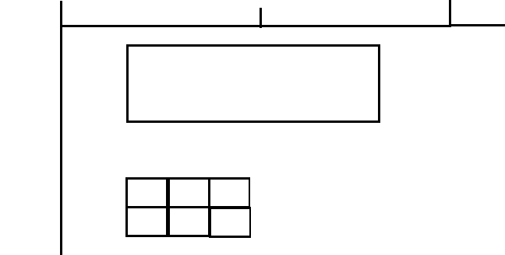

This **simple** layout grid shows the big rectangle/box being the newest picture, with a 3x3 grid of pictures below it. On the left, there will be links to posts and random pictures. On the top left, the title will be there. Next to it will be tabs to different features, and next to that will be signup/login.

5.2 Mood Boards

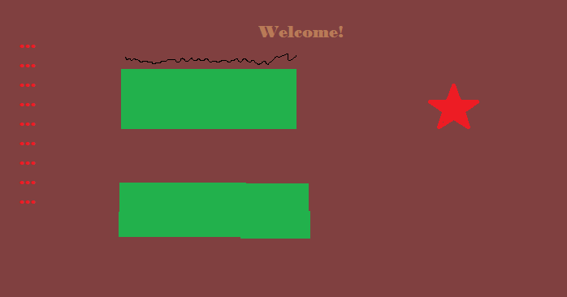

This shows how I want the website to feel. Mostly dark and warm colors. The star represents what will be the SDA logo (the bible and fire above it). The dots on the left represent links. And the dark squiggle represents the title of the main picture.

5.3 Page Mockups

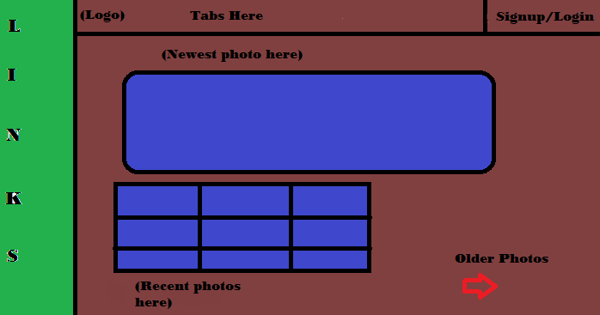

The page will look something like this (Simple Mockup)

**Appendix A:** No real competitors exist, but scripshots may be one.

**Appendix B:** The content will contain three major things: Lessons, photos, and posts about what is happening with the website.